**KPR TASK**

Name:Ramadurai R

# Reg No: 1P22MC039

# College:Rvs College Of Arts and Science,Sulur,Coimbatore

**HOME:**

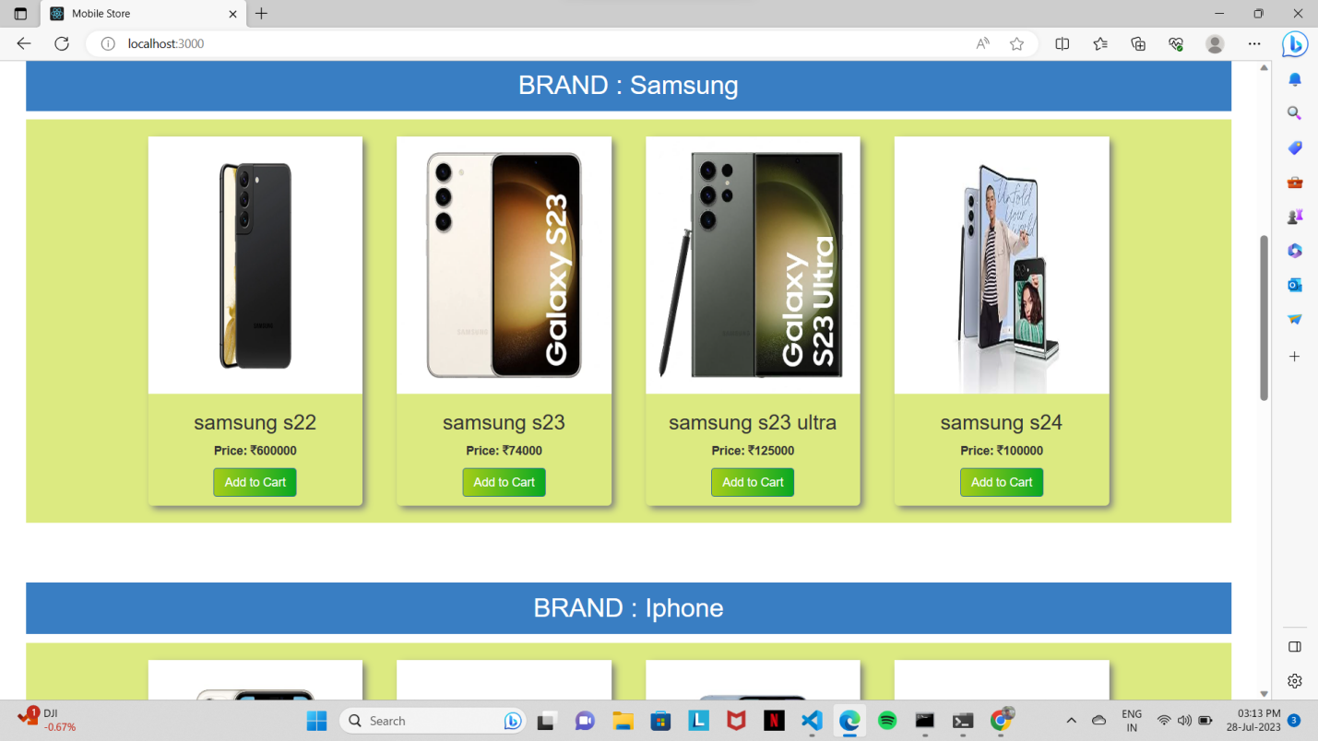

**ADD ITEM:**

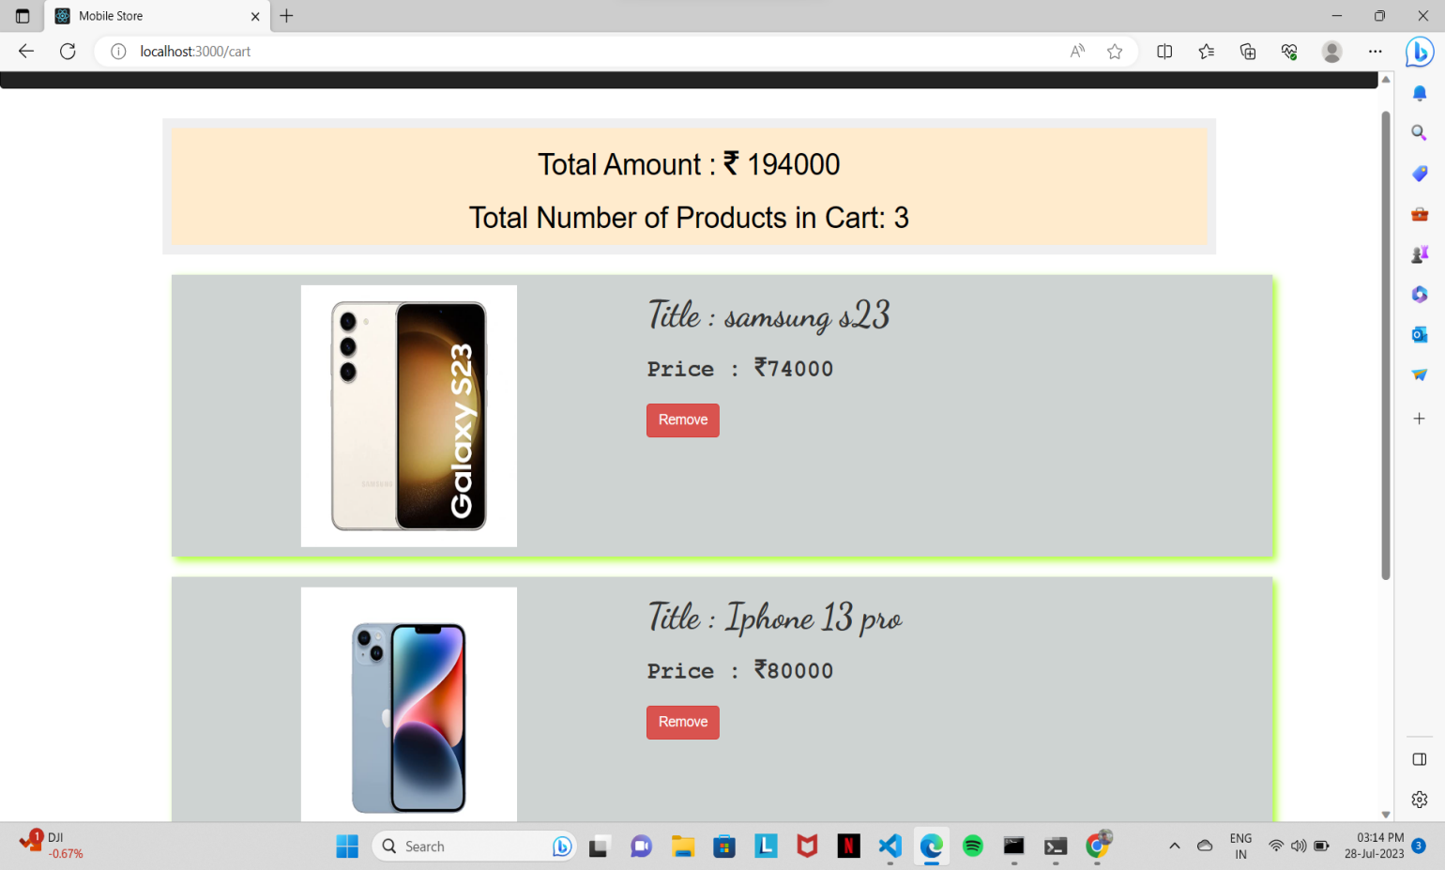

**REMOVE ITEM:**

